**John Munton G7SSE**

1. **General**

In this section USB interface, IC-7610 setup and Logger32 setup are explained.

1. **Setup**

**2.1 USB interface**

I am assuming at this point you have installed the drivers and connected the radio.

You will need to identify which of the two newly created com ports are which.

Open Device Manager in Windows;

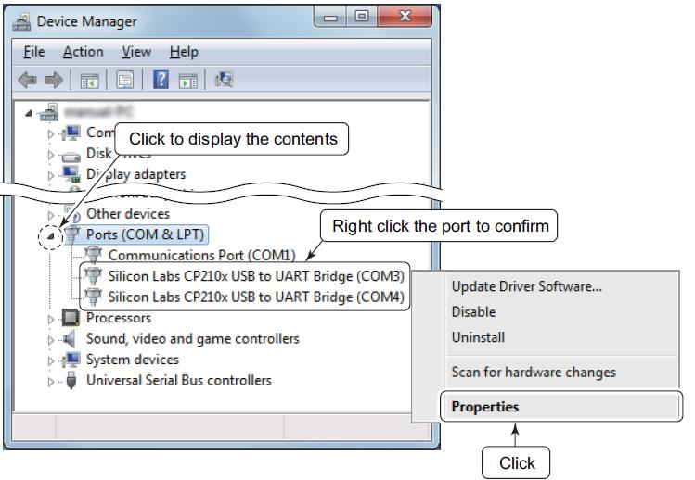

IC-7610_1

Click the 'Details" tab.

Click "Property" and select the "Device Instance Path" displayed in the drop-down list.  
Check the contents displayed in "Value."

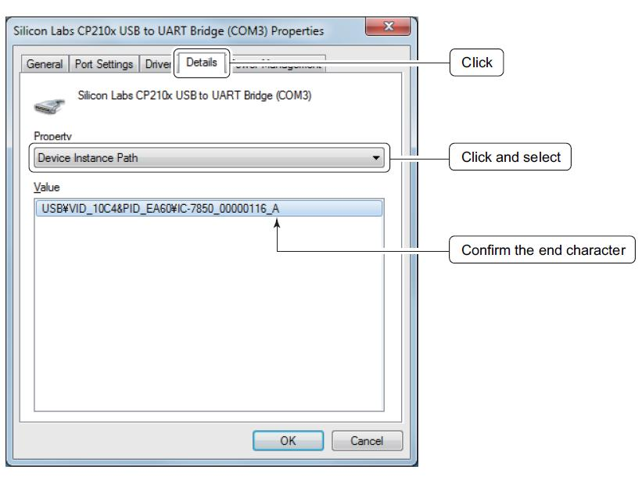

IC-7610_2

In my set up the A port (com3 in the above example) is the CAT port

and the B port (com4 above) is used in the radio’s USB Send/Keying menu for Digital Modes and CW keying, PTT etc.

**2.2 Setup in IC-7610**

My radio and Logger32 CAT settings are;

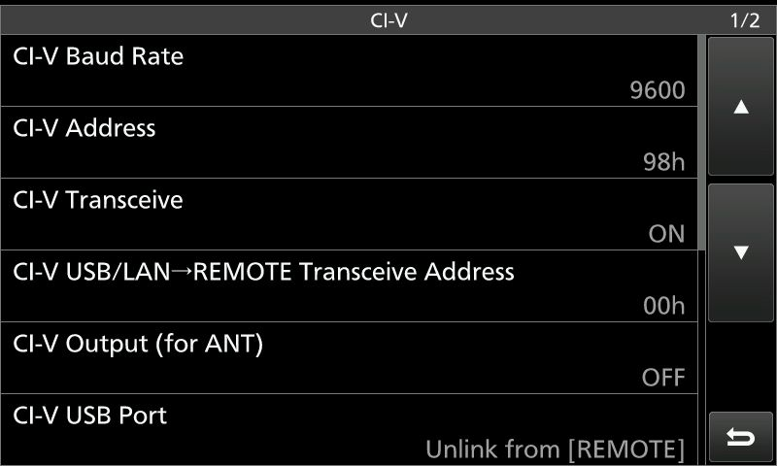

IC-7610_3

CI-V USB Echo Back MUST be set to ON for Logger32 to track frequency / band

changes.

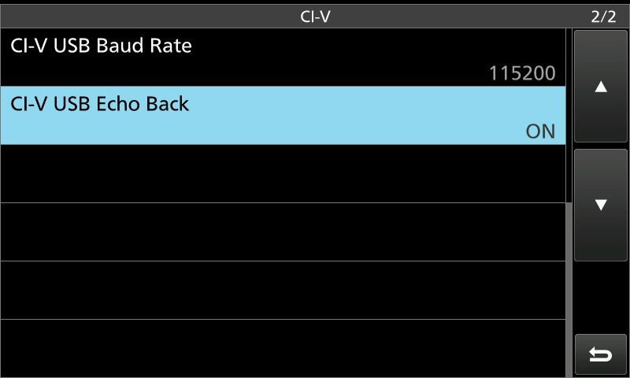

IC-7610_4

My Radio menu for USB Send/Keying.

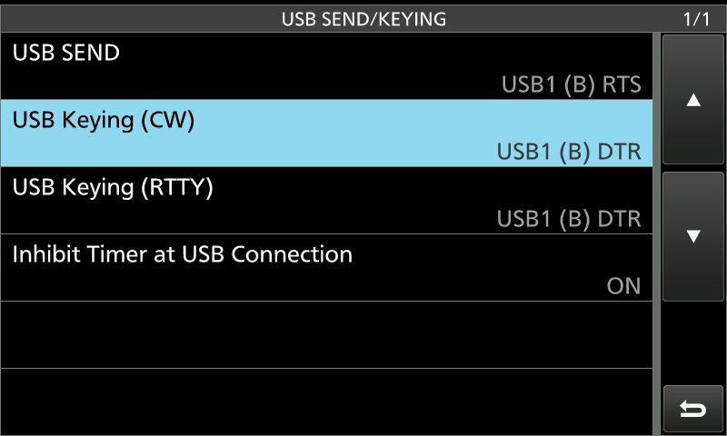

IC-7610_5

**2.3. Setup in Logger32**

Settings in Logger32. Select Com3 ( “A” port) as Com port.

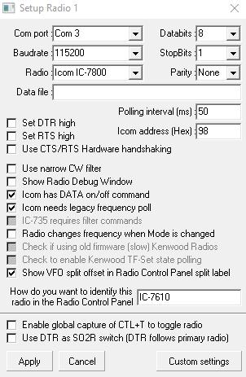

IC-7610_6

The com4 (“B” port) is used for Digital Mode / CW software for PTT, CW and FSK keying. Setup in USB SEND/KEYING menu. (IC-7610_5)